The Messenger
August 2026
Darlington United Methodist Church
Dave Bushfield, Pastor
Church phone: 765-794-4824 Website: www.umcdarlington.org
201 W. Harrison Street, P. O. Box 86, Darlington, IN 47940-0086
Mission: To make disciples of Jesus Christ for the transformation of the world
Vision: By being a visible sign of restoration and hope in this community
Open Hearts Open Minds Open Doors

A Shepherd’s Sharing:
WORD OF GOD SPEAK
For Christians, the Bible is the ultimate, God-breathed authority and the primary way God communicates His nature, love, and will to us. It provides us with the foundational narrative for our faith. It helps us shape our identity while giving us a moral compass as we experience the ebbs and flow of life. Most importantly, it helps us understand our relationship with Jesus.
We know that the Bible consists of 66 ancient texts divided into two testaments. The Old Testament (39 books) which details the history of ancient Israel and God's covenant with them. The New Testament (27 books) which focus on the life, death, and teachings of Jesus, and the growth of the early Christian church. The Bible was written by dozens of different authors over the time frame of approximately 1,500 years… written in Hebrew, Aramaic, and Greek.
Many of you are aware that as a Local Licensed Pastor, I am required to take Course of Study. The past two classes were very interesting… Theology 222 (which focused on the history and theology of the Church through the first five centuries) and Theology 322 (which focused on major movements and events beginning with the split between Eastern and Western forms of Christianity and continuing through the Reformation period). Imagine if the Bible never got translated into English…how would we learn? Thankfully, there were great men who dedicated their lives to learning and sharing the works of the Bible. These men often engaged in deep debate about the truths of God’s Word, and it cost some their very lives. I hadn’t understood the sacrifice of the early church theologians until now. I will never look at the Bible the same.
Yes, the Bible is a complex book. Everyone, to varying degrees, struggles in trying to understand it. Even after nearly 2,000 years of church history, there are some Bible verses and passages that leave even the most brilliant of Bible scholars speculating as to the exact and correct meaning.
“Why is it so hard to understand the Bible?” is a question many pastors receive. The reason that the Bible can sometimes be hard to understand is that we are all fallen beings - sin clouds and distorts our understanding and leads us to twist the Bible to our own liking. But there is hope.
Remember, as a believer in Jesus Christ, God’s Spirit indwells you (Romans 8:9). The same God who "breathed out" Scripture (2 Timothy 3:16-17), is the same God who indwells you and will open your mind to the truth and understanding of His Word if you rely on Him. This is not to say that God will always make it easy. God desires us to search His Word and to fully explore its treasures. Understanding the Bible is not always easy, but it is always eminently rewarding.
After completing my classes I felt as if I had received a gift or reward. And the good news is that it is a gift that I get to share with all of you. Thank you for being patient with me as I continue to learn and grow as your pastor. The goal is for us all to work and grow together in understanding God’s Word…the band Mercy Me has a song I love…WORD OF GOD SPEAK… YES LORD…SPEAK! We are all learning to listen.
In Christ,
~Pastor David

***********

August 2026
Scripture Reading
August 2, 2026, 10th Sunday of Pentecost
Psalm 17:1-7, 15
Romans 9:1-5
Matthew 14:13-21
Genesis 32:22-31


Sermon: Wrestleinsania

August 9, 2026, 11th Sunday of Pentecost
Psalm 105:1-6, 16-22, 45b
Romans 10:5-15
Matthew 14:22-33
Genesis 37:1-4, 12-28

Sermon: God Can Use Even Hate

August 16, 2026, 12th Sunday of Pentecost
Genesis 45:1-15
Psalm 133
Romans 11:1-2a, 29-32
Matthew 15:[10-20], 21-28

Sermon: Guest Speaker, Pastor Kathy Martin

August 23, 2026, 13th Sunday of Pentecost
Psalm 124
Romans 12:1-8
Matthew 16:13-20
Exodus 1:8-2:10

Sermon: Among the Reeds

August 30, 2026, 14th Sunday of Pentecost
Psalm 105:1-6, 23-26, 45b
Romans 12:9-21
Matthew 16:21-28
Exodus 3:1-15

Sermon: The Burning Bush

***********

Worship Service – 9:00 a.m.
Fellowship Time – 10:00 a.m.

***********

For God is at work within you, helping you want to
obey Him, and then helping you do what He wants.
Philippians 2:13

August Birthdays and Anniversaries
Happy Birthday and anniversaries to all our
members and friends who have birthdays or anniversaries this month. You are in our thoughts and prayers.

May God lead you and guide you always . Long life is in your right hand; in your left hand are riches and honor.
Proverbs 3:16

***********


Dates to Remember
SPRT/Ad Council, 5 p./6 p. August 5
Ark Groundbreaking, 5:45 p. August 14
Guest Speaker, Pastor Kathy Martin August 16 Newsletter Items Due August 18
Colfax Hickory Comm. Dinner, 6 p. August 20
Dinner at the Community Center August 30
Relay for Life September 5

***********

First Name Holidays
National Michael Day August 3
National Dean Day August 10
National Pamela August 22
National Dan Day August 31

***********

Silly Dates to Remember
National Watermelon Day August 3
National Chocolate Chip Cookie Day August 4
National Root Beer Float Day August 6

National Raspberries in Cream Day August 7
National S’mores Day August 10
National Raspberry Tart Day August 11
National Sewing Machine Day August 12
National Filet Mignon Day August 13
Color Book Day August 14
National #2 Pencil Day August 17
Serendipity Day August 18
National Soft Ice Cream Day August 19
Poet’s Day August 21
Can Opener Day August 24
Touch-A-Heart Tuesday August 25
National Cherry Popsicle Day August 26
National Banana Lovers Day August 27
National Bow Tie Day August 28
Eat Outside Day August 31

**********

Announcements for the Bulletin
Please contact Dustin Gardner at 317-220-7667 or dustin-gardner@gmail.com by Wednesday, if you need any announcement included in the bulletin on the following Sunday morning.

**********


What’s Coming Up . . .
Wednesday Morning
Ladies Bible Study

Ladies Bible Study:
We have jumped into some uncharted territory as we leave Daniel and the Old Testament and head straight toward the end of the book and the New Testament. That is right! We will be studying this wonderful writing of John’s, Revelation, for the next several months.
It’s a great time to join!
Hope to see you Wednesday mornings in the church basement at 9 a.m. The coffee will be provided to get our minds in gear and the fellowship is so encouraging to all. It is only an hour of teaching with fellowship to follow if you want to stay.
Come and join the fun! If you have any questions, contact me by text, email or phone.
Diana Binford
************

In Memory Plaque Announcement

We are pleased to announce that our church will be creating an In Memory Plaque to honor and remember our beloved past church members who have gone before us. This plaque will serve as a lasting tribute to their faith, service, love, and dedication to our church family.
If you would like to have a loved one remembered on the plaque, please submit their name to Denise Maxwell (denisekmaxwell@gmail.com or share with me at church.)
May this memorial be a meaningful reminder of the lives, love, and faithful witness of those who helped shape our church community.
Blessings,
SPRT Committee

**********

Prayer Room
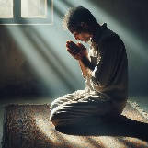
We are excited to announce the opening of our new cozy little prayer room. The new prayer room is located through the door on the right side of the sanctuary. This special space is available for anyone seeking a quiet place for prayer, reflection, and spiritual renewal.
If you would like someone to pray with you feel free to reach out to Pastor Dave or one of your church family members.
We will have prayer request cards located in our prayer room. Feel free to fill out and place in the collection plate or leave in a basket located by the cards. Share as much or as little as you feel comfortable with. Our church is a praying church, and we want to ensure everyone has prayer support.
Have a blessed summer.
Blessings from your Pastor Parish Committee

**********

Sunday Dinner
at the Community Center
Mark your calendars. There will be a Dinner at the Community Center on August 30, 2026, from 11:30 a.m. to 1:30 p.m.. Come and enjoy the meal and great fellowship with our neighbors. A free-will donation is always welcomed.
Donations of desserts and/or another side dish are always welcome. If you have a favorite salad or dessert you would like to share with the community, please bring it to the Community Center before church.
Thank You.

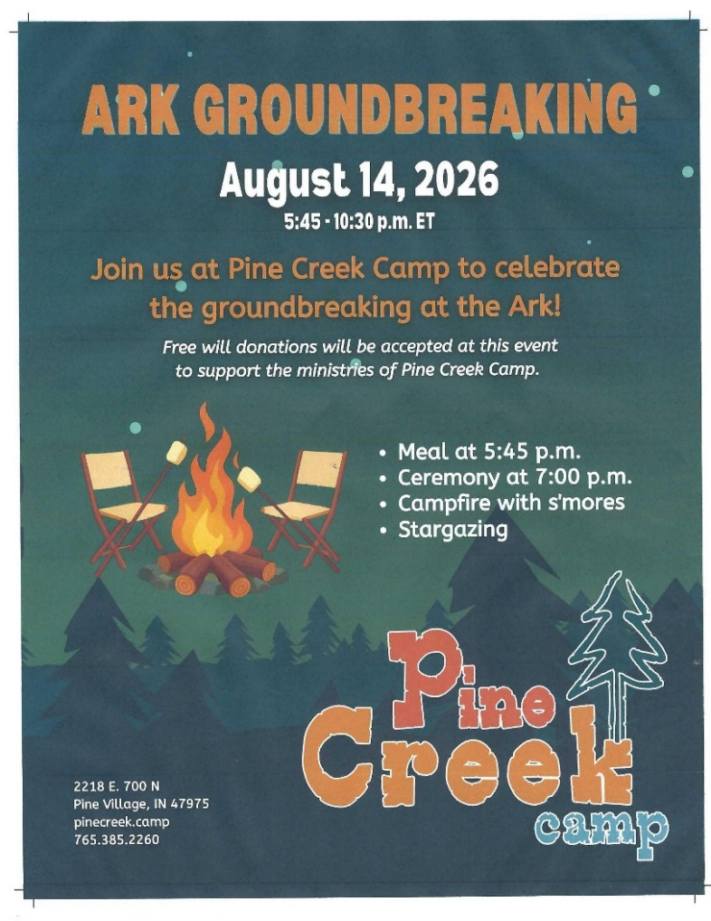
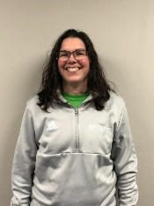
Kathy Martin, Guest speaker
for Colfax and Darlington
on August 16, 2026
Kathy Martin will be delivering the message on Sunday, August 16, 2026. If you were fortunate to be there on May 24th when she filled in for Pastor David, you were blessed with a wonderful message.
We are pleased to have Kathy return to fill in for Pastor David again on the 16th. Come and hear what Pastor Kathy has to tell us.

**********

Colfax Hickory Community Dinner
2026 Schedule
As you plan for the upcoming year, we would love it if you would consider taking time to join us for sweet fellowship and good food once a month at The Gathering Place in Colfax Indiana. As always, we appreciate any free will donations that people contribute to help us with the cost of the food.
This year, we would like to see if there would be any businesses willing to become a corporate sponsor for a meal for one month. We will gladly advertise your company name on each table with any generous gift to the ministry.
The following dates are when we are scheduled to gather together at 6 p. m. on the 3rd Thursday of the month (except for December)
August 20th September 17th October 15th
November 19th December 3rd

The kind and loving people of Colfax United Methodist Church invite everyone to come and eat. Our goal is simply to build relationships with our neighbors and spread the love of Jesus.
Together we can make a difference!
Pastor David Bushfield

***********


Montgomery County’s
Relay for Life
I am proud to be participating in Montgomery County’s Relay for Life, an event that brings our community together to honor survivors, remember loved ones we’ve lost, and raise fund’s for the American Cancer Society’s life-saving work. This year’s event will be held on Saturday, September 5th.
Cancer touches so many lives in so many ways – including my own. Thay’s why I’m committed to walking, fund raising, and spreading hope. Every dollar raised helps fund groundbreaking research, provide free support services for patients and their families, and promote prevention programs that save lives. All money raised at our local Relay for Life stays in Montgomery County.
I would truly be grateful if you could support my efforts with a donation. Your generosity will help bring us closer to a world without cancer. You can make a secure donation online at relayforlife.org/montgomerycountyin, please search for my name or you can mail a check, made out to the American Cancer Society, 9979 East 450 North, Darlington, IN 47940.
Thank you for standing with me in this fight against cancer. Together we can make a difference.
With heartfelt gratitude,
Cheryl Greene

Relay For Life: there is no finish line until there is a cure!

***********

An Invitation
Good afternoon,
My name is Gillian Jackson, and I serve as the Program Manager for Pine Creek Camp. I would like to extend a warm invitation to you and your congregation to join us for our groundbreaking ceremony on Thursday, August 14 at 5:45 p.m. – 10:30 p. m.
This is an exciting milestone for Pine Creek Camp, and we would be honored to have your church celebrate with us as we look ahead to the future of our ministry.
Please look at the flyer above for additional details about the event and the day's festivities. We hope you will be able to join us for this special occasion.
If you have any questions, please feel free to reach out. We look forward to celebrating with you!
Thank you,
Gillian Jackson
gillian.jackson@impact2818.com

***********


My School Promise
Each day I’ll do my best
And I won’t do any less.
My work will always please me
And I won’t accept a mess.
I’ll color very carefully,
My printing will be neat.
And I will not be happy
Until my work is all complete.
I’ll always do my homework,
with learning as my quest.
I won’t forget my promise
To always do my best.

***********

Pastor Dave’s Office Hours
and Reachability
Church…Please know I am here for you. ALL OF YOU! I have had people say things to me like, “with three churches, I don’t want to interrupt you…or I don’t want to bother you.” While I appreciate the sentiment and care you all have for me, it is important that you know that I am available to you as your pastor.
I want to be there for you when you need me.
EMAIL ME AT: dave.bushfield@inumc.org
CALL OR TEXT ME AT: 765-426-6271
STOP AND VISIT ME AT:
MONDAYS 9 am to 2 pm Rossville United Methodist Church
TUESDAYS 9 am to 2 pm Colfax United Methodist Church
WEDNESDAYS 9 am to 2 pm Darlington United Methodist Church
THURSDAYS WORK FROM HOME OR VISITATIONS
FRIDAYS DAY OFF
SATURDAYS MY SABBOTH DAY
SUNDAYS Darlington 9 a, Colfax 10:30 a, Rossville 12:00 p

There may be times when I am unavailable, if that happens, please leave me a message and I will get back with you. Caring for your spiritual needs and concerns is part of what we do as pastors. It is my honor to be your pastor and help care for you!

(On Friday or Saturday, if there is a ministry need, please contact the Staff Parish Chairperson for any ministry needs for your prospective churches. I will not take calls on these days in order to maintain my spiritual and physical health…thank you for understanding.)

SPRT CHAIRPERSONS:
Darlington UMC: Denise Maxwell 765-918-5227
Colfax UMC: Tammy Greiger 317-989-8599
Rossville UMC: Gary Hathaway 765-564-0102

**********

Church Business
Our next meeting
will be on
Wednesday,
August 5th
at 6 p.m.

***********

SPRT/Ad Council Upcoming Dates for 2026
August 5 October 14 December 9

***********

Financial Report
January – June 2026 (YTD)
Thank you for your blessed giving. Jesus is our shepherd and together we will become a strong body. Take time to reflect on what he endured for our salvation. Nancy Weliever, Treasurer

God is good – All the time.
All the time – God is good.

***********

"Almighty God, You are holy and deserving of all honor.
Your power is unmatched, and Your wisdom infinite.
I lift my voice in exaltation, knowing You are the King of Kings
and Lord of Lords. To You be the glory, forever and ever. Amen."

History of Serendipity Day

The word serendipity was coined in the mid 1700s by a man named Horace Walpole. In a letter to a friend, he explained how he had created the term from a Persian fairy tale known in English as The Three Princes of Serendip.
The story tells of three princes who were banished from the kingdom of Serendip (another term for Sri Lanka) in order to have a chance to prove their worth.
As they wander the world, “serendipitous” moments occur to them time after time, in a rather unbelievable amount.
In fact, it is much like many children’s stories in that the characters often just happen to run across the perfect place or the clue to solve the mystery. Or it could be likened to old, corny superhero movies, where they just happen to have the antidote to the problem lying around!
In other words, it seems that Walpole first created the word serendipity as some mild ridicule of these “happy accidents” and now the term is a favorite inspirational line everywhere: “seek serendipity!”
Thus, Serendipity Day encourages people to look for and notice those unexpected good things that are always out there, if people would just have the eyes to see them.
In fact, the creators of this lovely day believe that serendipity is no accident at all, but an attitude or a lifestyle in which people are always reaching for those unexpected things and expecting happy surprises to occur.

***********

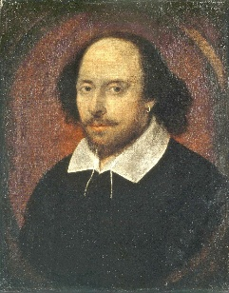
History of Poetry
At its most base description, Poetry is a form of writing that uses the aesthetic and rhythmic qualities of a language, combined with simile and metaphor, to bring out meanings deeper than the mere definition of the words.
The history of poetry is lengthy, traceable in written form as far back as the Sumerian Epic of Gilgamesh, and has been used as a memetic method of passing down stories and mythologies throughout cultures for countless ages before that. The question of “What is Poetry?” has been a question that has vexed philosophers for time out of mind, with Aristotle writing a book aptly named Poetics, trying to define it.
However he was only able to address a small portion of what poetry is, and how it is used in rhetoric, song, drama, and comedy. One of the greatest poets of all time heralded from England, along the Avon river in the aptly named Stratford-upon-Avon in south Warwickshire, England.
This, of course, was the man who was to come to be known as ‘The Bard’, William Shakespeare. His body of work is the foundation for the study of poetry in college’s throughout the world, and is considered to be the absolute pinnacle of the art by many.
Such was the love of ‘The Bard’s works, that during the time of the Victorian’s, the term ‘Bardolotry‘ was used to describe their love of his works. Perhaps the most important lesson to take from the Bards rise to prominence in the world of Poetry and literature lay in the time it took for his works to become legend.
It wasn’t until the 19th Century, hundreds of years after his death, that Shakespeare became the legend we know today.
History of Poetry Day
Poetry Day was founded by William Sieghart in 1994. He is a British philanthropist, entrepreneur, and publisher. He also founded Forward Prizes for Poetry. This is a major award ceremony for poetry, which is presented once a year.

**********

From Esther
Remaining in the Love of Christ
Dear sisters and brothers in Darlington,
The older I get, the more I realize that the essence of faith is not how much we do for God, but how deeply we allow ourselves to be loved by him.
We often spend many years serving God. We work in the church, take on responsibilities, pray, help others, and try to follow Christ. All of this is important. But before Jesus sent out his disciples—before they were to change the world—he said something very simple: “Just as the Father has loved me, so have I loved you. Remain in my love.” (John 15:9)
Not: “Try harder.”
Not: “Be more successful.”
But: “Remain!”
These words touch my heart time and again. For to remain means to linger. It means allowing Christ to look upon us without having to prove ourselves. It means becoming still and knowing: “I am loved.”
Jesus did not love his disciples only after they had understood everything. He loved them along their journey. He loved Peter despite his failure. He loved Thomas despite his doubts. He loved them to the very end.
And that same love is for us.
Perhaps as the years go by, we feel more clearly that our strength is waning. What used to come naturally now takes time—or is no longer possible at all. Some journeys grow shorter; some nights grow longer. There are goodbyes, silent tears, and questions to which there are no easy answers.
It is precisely then that Christ speaks His gentle word into our hearts: “Remain in my love.”
This is not a command, but an invitation to place our lives in His hands again and to find peace in the fact that we belong to Him.
John Wesley once wrote that God’s love can fill a person’s heart so completely that it permeates their entire life. This love is not a fleeting feeling. It is the presence of Christ within us. It makes us gentle. It gives us patience. It enables us to forgive. It teaches us to trust even in difficult times.
The longer we walk with Jesus, the more we may discover that our greatest calling is not to accomplish great things, but to reflect His love. A person who rests in Christ becomes a place of peace for others.
Sometimes a silent prayer is enough.
Sometimes a blessing.
Sometimes just a hand to hold.
That, too, is Christ’s love in action.
The Apostle John writes: “We love because he first loved us.” (1 John 4:19)
That is the source of our faith. It is not our love that sustains Christ, but His love that sustains us. It always has. And it will continue to do so until the day we see Him face to face.
May we hear the quiet voice of our Lord again in the days ahead: “Christ has no hands but ours, no feet but ours. Yet before we become His hands for the world, may we place our lives trustingly in His hands.” (14th-century prayer)
With this trust, I wish you the peace of Christ, which is deeper than all worries, and the joy that grows from His presence.
With heartfelt blessings for a fulfilling summer,
Your sister in Christ,
~Esther

***********

“Wait on the Lord: be of good courage,
and he shall strengthen thine heart.”

When I don’t know what to do, Father,
help me wait for my instructions. Amen
A NOTE FROM THE PASTOR:
- I met with the new West Central Plains District Superintendent, Tom Ream, on Thursday July 16th at Mulberry UMC. We had a wonderful time getting to know each other better. He is excited to hear how God is using our churches in the communities we are in. He wanted you all to know that he is supportive of the call God has placed on us but asked us to continue to keep praying to make sure we are doing exactly what God has called us to do and be. I assured him we would be diligent in pursing the things God desires for our churches. Please pray for DS Tom as he is new to his role. May we join together in seeking God to bless him and help his learning curve be guided by the Holy Spirit.
- Another note…I will be on vacation from August 10th through August 22nd. Please feel free to reach out to me via text, email, or phone at this time. Just be aware that my response time will likely be extended. In the event of an emergency, please contact the SPRT chairperson of each church if you are unable to reach me.

Darlington and Colfax will have guest speaker Kathy Martin on August 16th. She filled in for me while I was gone in May. She is back by popular demand. Rossville will have Pastor Kevin Smith preaching (who is currently pastoring in Mulberry) on that day. Please make sure to come and worship with these wonderful minsters of God. You will miss out on something special if you don’t come.

- Thanks!!!! Thank you for joining us at the Family Fun Day at Columbian Park on July 11th. Around 40 people came and had fun. We will do this again next year! Look for it on the calendar next July.

Special thanks to Greg Woodruff of RUMC for making some real good BBQ for us!
I am looking forward to some rest and relaxation of vacation. I would appreciate your prayers as I recharge my batteries. Thank you for your support and love. ~ Pastor David

***********

A Living Document
Karen Pimpo

Blessed is the one . . . whose delight is in the law of the Lord,
and who meditates on his law day and night.
Psalm 1:1-2

In memorializing his grandfather’s work, Peter Croft wrote, “It is my deepest desire for the person who picks up their Bible, whatever version they use, to not only understand but experience the scriptures as living documents, just as relevant, dangerous, and exciting now as they were those thousands of years ago.” Peter’s grandfather was J. B. Phillips, a youth minister who undertook a new paraphrase of the Bible in English during World War II in order to make it come alive to students at his church.
Like Phillips’ students, we face barriers to reading and experiencing Scripture, and not necessarily because of our Bible translation. We may lack of time, discipline, or the right tools for understanding. But Psalm 1 tells us that “Blessed is the one . . . whose delight is in the law of the Lord” (vv. 1-2). Meditating on Scripture daily allows us to “prosper” in all seasons, no matter what hardship we’re facing.
How do you view your Bible? It’s still relevant with insight for living today, still dangerous in its call to believe and follow Jesus, still exciting in the intimate knowledge of God and humanity that it imparts. It’s like a stream of water (v. 3) that provides the sustenance we need daily. Today, let’s lean in – make time, get the right tools, and ask God to help us experience Scripture as a living document.
Missions
We have several opportunities for you to get involved. Each opportunity is a wonderful way to reach out to the community around us. But please, don’t feel that you must be involved in every project that is offered. Pick what you are passionate about and give whatever support you can. Thanks for your help.

***********


Backpack Program
School begins soon, so we will be packing the backpacks again. We will pack the backpacks for the weekend every Thursday at 3 p.m.
We have sufficient funds for shopping for anyone wishing to help, so please contact Lynn Cox. Drinks and cereal deplete rapidly, since we send out milk and juice each week. Cereal in individually packed bags are also given out at that rate each week also.
Thank you all for whatever help you have done or can do to help with this project.

***********


Project: Be a Fisherman
On the table in the front entrance we have placed some material that anyone can pick up. There are pamphlets, Daily Bread devotionals and crosses. These are materials you can hand out as you have an opportunity. Denise Maxwell

**********


PB&J Mission
The PB&J Mission is going well. Thanks to everyone who donates to this worthwhile mission.

**********

The Kid’s Closet

The Kids Closet is a ministry based in Montgomery County, IN. Jennifer Pruett started this in Crawfordsville a few years ago. I am happy to be able to be a part of this worthwhile mission.
Our Mission is to provide gently used and sometimes new clothing to all children in Montgomery County who have a need. The ages range from newborn to 18. Families fill out a google form to request clothes. Our goal is to provide the children with 10 outfits including socks and underwear to have plenty to wash and wear throughout the week. There is no charge for the clothing. Families learn of this by word of mouth, but our hope is for us to get the schools to help us learn of families that need some help. We give weather appropriate clothing, including shorts, jackets, school clothes, etc.
The Kid’s closet is open now, and we take clothes from preemie to 14/16, We have had some requests for up to size 20, though. Right now, we’re doing a sock drive, if anyone would like to donate new socks. We’re always accepting donations be it clothing or monetary. If you look on Amazon, you can also find a wish list for The Kid’s Closet.
Thanks for your help. Darsey Gardner

**********

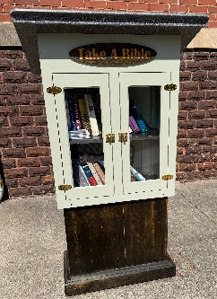
Take a Bible/Give a Bible Box
"Take a Bible/Give a Bible Box" located on the east side of the church, established by Diana & David Binford and Gary Cox.

Purpose: The box is available for people to both donate and
take Bibles and Spiritual books.

Donation Guidelines:
Accepted Items: Gently used Bibles and spiritual books are accepted.
Preparation: Donated items should be placed individually in plastic bags
to protect them from the weather.
Availability: Anyone who needs a Bible or a spiritual book is welcome to
take one.

**********

Guatemalan Project
Here is the latest news!!
We have learned from our Guatemala contacts, that they have received a new EKG machine this year. Glenn reports that this is such a blessing because it keeps people from having to drive long distances when they need this test.
He also said to tell everyone that they are making a huge difference for the folks in that community.
So, if you have any questions about Guatemala, I will connect you with Glenn. He is so excited about the work being done there.
Let’s keep doing all that we can to support our friends in need!
Diana L. Binford
765-918-0356

Doing all the good we can together...
Glenn Howell

**********

National Safe Haven Alliance
Kroger Community Rewards

The Kroger Family of Companies is committed to community engagement, positive social impact and charitable giving at the national and local levels. Every community is unique, but our common goal is to partner with the neighborhoods we serve and help the people there live healthier lives.
One of the ways in which we do this is through our Kroger Community Rewards program. This program makes fundraising easy by donating to local organizations based on the shopping you do every day. Once you link your Card to an organization, all you have to do is shop at Kroger and swipe your Shopper’s Card. Here’s how it works:

Whether you’re a customer or an organization, get started today!
Note: If you are a customer, make sure you have a preferred store selected to view participating organizations. If you are applying on behalf of an organization, please select a store in the same area as your organization.

***********

Day by day, . . . they broke bread at home and ate their food with glad and generous hearts, praising God. Acts 2:46-47

To God who gives our daily bread
A thankful song we raise,
And pray that he who sends us food
May fill our hearts with praise. ~ Thomas Tallis
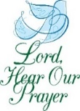
Please remember the following members and friends of our church family in your daily prayers. If you need to add or delete any name from this list, please contact Diana Binford at
765-918-0356 or TEXT Marsha Wells at 765-918-9148.
Thank you for your continued prayer.

Praises: So many prayers answer!
Christ the Lord is Risen!
40 people attended the community church outing at Columbia Park
4-H Fair was fun, educational, and a safe place for children
Concerts with college buddies was well attended
Good Surgeries
Granddaughter had a good volleyball team experience
Healing and in rehab
Many answered prayers
Many celebrations of our nation’s 250th birthday
Teacher and her students had a safe and successful trip to Costa Rica

**********

Other prayer needs:
A need for volunteers to help with Nursery
Children in backpack ministry – needs met
Community, State, Nation, World and all the leaders
– May they make God-led decisions
Those injured in house fire and loss of her husband and son
Darlington UMC, Colfax UMC, Christ UMC, Rossville UMC and UMC at
large, East Naples UMC, Congregational Church, and East Christian
Church
Families of those who have passed on.
Farmers
Losses of everything in storms
Kid’s Closet
Kids who don’t have a safe place for summer
Loss of everything due to house fire
Our Guatemalan children/Our Guatemalan Project
Rebuilding Creekside Restaurant
Those in foster care and all the challenges they face
Those in northern Indiana – around the Kouts, IN area
Victims in Haiti, Iran, Israel, Maui, Nigeria, Syria, Turkey, Ukraine, and
Venezuela
Victims of dust storms, floods, and tornadoes, wild fires
Victims of hate crimes and discrimination
Victims of the Texas Floods

**********

Those in treatment or suffering with cancer
Those with other health needs
Those Serving in the military:
All those being deployed and all our military, home or overseas

**********


Dear Father, We lift up all those who are facing illness or other adversities in their bodies and minds today. We ask that you bring comfort, peace, and healing. Surround them with your love and touch their bodies with your healing hands. Amen

**********

Our Shut-In List
Our Shut-Ins, listed below, need their days brightened with visits, mail, calls, and including them in your daily prayers.

God Finds Us Usable
Isn't it amazing to think that the God of the Universe finds us usable. He's given us specific gifts and abilities for reaching out to others. He could have chosen a thousand other ways to reach the unsaved, but the Lord picked us! Thank you for your service to our church.

Liturgist
August 2 Dan Maxwell
August 9 Lynn Cox
August 16 Dan Hampton
August 23 Sarah Boeh
August 30 Mary Lou Weliever

September 6 Diana Binford
September 13 Dan Maxwell
September 20 Lynn Cox
September 27 Dan Hampton

**********

Scripture Reader
August 2 John Wells
August 9 Kim Warren
August 16 Kathy Hampton
August 23 Steve Greene
August 30 Lynn Robison

September 6 Tracy McHenry
September 13 Cheryl Greene
September 20 John Wells
September 27 Kim Warren

**********

Nursery
If you can’t be in Nursery,
please call someone on the list to trade.
Thank you.

August 2 Cheryl Greene
August 9 Diana Binford
August 16 Jaysee Shaw
August 23 Lynn Cox
August 30 Darsey Gardner

September 6 Cheryl Greene
September 13 Tracy McHenry
September 20 Jaysee Shaw
September 27 Lynn Cox

**********

Fellowship
August 2 John and Marsha Wells
August 9 David and Diana Binford
August 16 Ryan and Tracy McHenry
August 23 Dan and Kathy Hampton
August 30 Dustin and Darsey Gardner
Fifth Sunday Dinner/Comm. Center

September 6 OPEN
September 13 Mary Lou Weliever
September 20 Dan and Kathy Hampton
September 27 David and Jeanette

**********

To love is to place our happiness
in the happiness of another.
--Gottfried Wilhelm Van Lubreitz

